NewtonianMechanics
Mass distribution and point of application
of forces of a dynamical system clearly affect the resulting motion and
must be taken into account. The motions are found by solving the system
equations of motion that form the cause/ effect model between the forces
acting on the system and the resulting translational, rotational, and deformational
accelerations.
Newton's First Law: Unless acted upon by a force, a particle will maintain a
straight line motion with constant inertial velocity.
Newton's Second Law: Let the vector F be the sum of all forces acting on
a particle having a mass m with the inertial position vector r. Assume that
N is an inertial reference frame, then
Nd
F = dt (mr)
F=dp/dt while p is momentum
If mas is constant, f= mr’’
that all derivatives taken in Newton's second law must be inertial
derivatives
Newton's Third Law: If
mass m1 is exerting· a force F21 on mass m2, then the
force F12 experienced by m1 due to interaction with m2 will be
f12=-f21
Newton's Law of Universal Gravitation: Let the vector r12 = r2 - r1
describe the position of mass m2 relative to mass m1
Then the mutually attractive gravitational force between the objects will be
$F12=-f21=\frac{Gm1m2}{{\left|r12\right|}^{2}}\frac{r12}{\left|r12\right|}$ g is universal gas constant =~ 6.6732 x 10-11
the law of universal gravitation is that the gravity
force is conservative and can be calculated from a gravity field potential energy function
$∇V\left(r\right)=-\frac{Gm1m2}{\left|r12\right|}$

Single Particle Dynamics
After integrating the velocity formulation, an expression for the time varying position vector r(t) of the mass mis found:
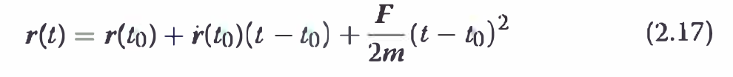
Time-Varying Force
g the time required to accelerate from one velocity to another or to travel from one position to another under the influence of F(t) cannot be found generically as for the case of constant F
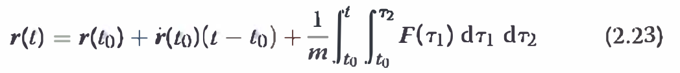

Kinetic energy

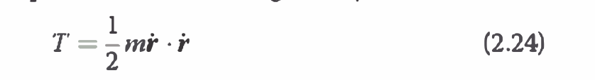
If the force F is conservative, it can be expressed as the negative gradient of a potential function V:
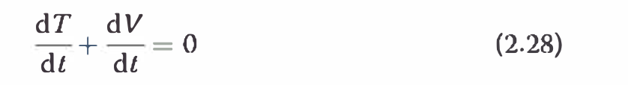
Linear momentum
The momentum measure provides a sense of how difficult it will be to change a motion of a particle
P=mr’
the force acting on a particle can be defined as the inertial time rate of change of the linear momentum of the particle

If no force is acting on the particle, then jJ is zero and the linear momentum is constant
Angular Momentum
Let P be an arbitrary point in space with the inertial position vector rp
and let the mass m have an inertial position vector r.
The angular momentum vector Hp of the particle m about point

Lp due to force F about point P.
if the reference point P is inertial (nonaccelerating), is reduced to the famous Euler's equation .Hp=Lp
Dynamics of a System of Particles
If m varies with time, then mass
particles are ejected, and the system must be considered a multiparticle system.
Equations of Motion
The system center of mass position vector Rc
ri, = (Ri - Re) is the position vector of mi relative to Re,

the superparticle theorem:
T'he dynamics of the mass center of the system of N particles under the influence of the total external force vector Fis the same as the dynamics of the superparticle M.
tracl<s only the center of mass motion of the system. No information
is obtained about the size, shape, or orientation of the cloud of
N particles.
Kinetic Energy
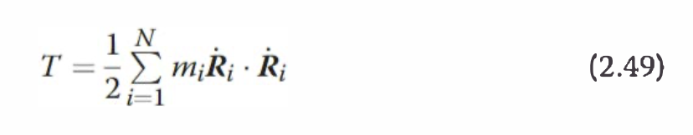
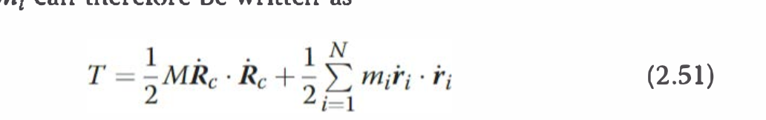

the first term contains the system translational l<inetic energy and the
second contains the system rotation and deformation l<inetic energy.
If the
total resultant force Fis itself a conservative force due to a potential function
V c(Rc)
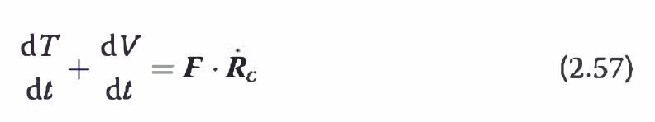
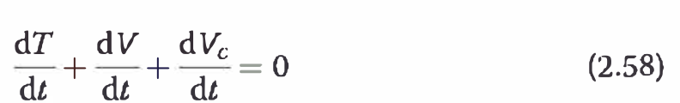
The first term on the right-hand side of Eq. (2.60) is the translational work
done, and the second term is the rotation and deformation work done on
the system
Linear Momentum
The linear momentum of the mass center of the system of N particles is the same as the linear momentum of the superparticle M
If no external force F is present, then the total system linear momentum vector p will be constant.
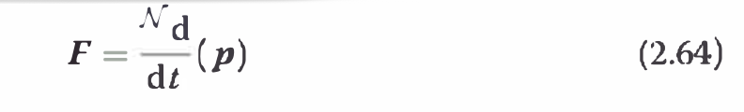

Unless an external force is acting on a system of N particles, the total linear momentum of the system is conserved.
he total
system energy is not conserved during the collision. However, momentum
is conserved and can be used to compute the velocities of the bodies after
the collision
Angular Momentum
Let's find the angular momentum
of the N particle system about an arbitrary point given by the inertial position vector Rp.
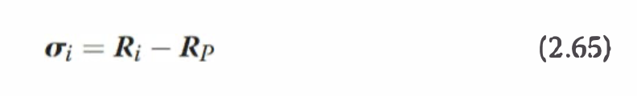
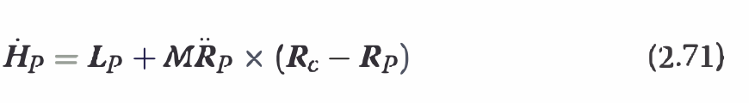
if either Re = Rp or Rp is nonaccelerating inertially, then Eq. (2.71)
reduces to the most familiar Euler equation
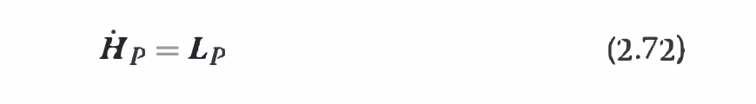
if no external torque
Lp is acting on the system of particles, then the total angular momentum vector Hp is constant.
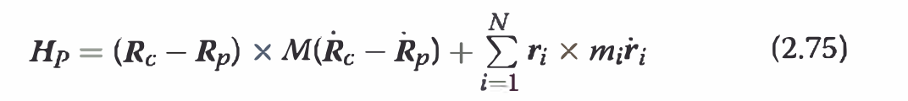
. If the point P is the origin O of an inertial frame, then
Rp = Rp = 0, and


The middle term is the rigid body component of the angular momentum,
while the third term is the angular momentum due to the particle cluster hape deformation. If the particles are frozen relative to the body B with
r' = 0, or the deformations are such that r and r' are parallel, then the
angular momentum reduces to

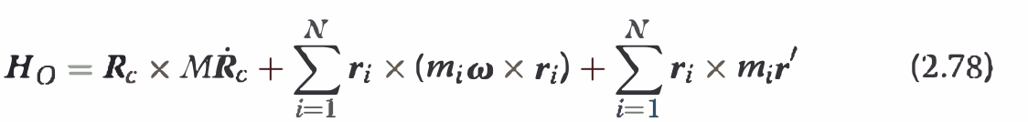
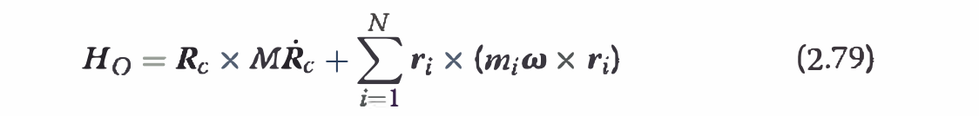

Dynamics of a Continuous System
Equations of Motion
The development of the dynamical equations of motion of a continuous
system parallels that of the system of N particles. Any finite sums over all particles
are generally replaced with volume integrals over the body B.
control volume that contains the instantaneous mass of
the system when actually carrying out volume integrations. at its volume contains all possible
deformations of the continuous dynamics system.
This allows for B to be considered time-invariant volume which simplifies the time differentiation of integrated volume measures.

f the control volume were to only encompass the deformable body, then
B would need to be treated as a time varying volume. In this case
differentiating J 8 Rdm would require the use of Leibniz integral rule [7] or
more generally Reynolds transport theorem [8]. Using the time-invariant
control volume B avoids this issue and leads to the classic dynamical
systems results shown.
Kinetic Energy
Let the inertial vector R define the position of the infinitesimal mass
element dm. The l<inetic energy of the entire continuous body B is then
given as
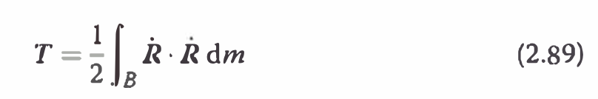
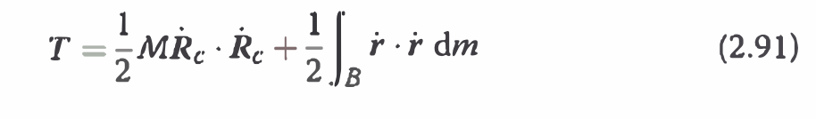
The first term in Eq. (2.91) represents the translational l<inetic energy,
and the second term represents the rotational and deformational energy.
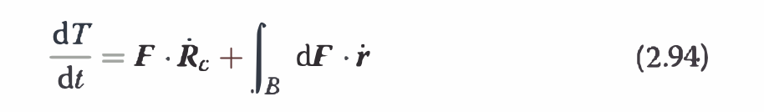
the first term expresses the translational work and the second term is
the rotational and deformational work done on the system.

Linear Momentum
To determine the total linear momentum of a continuous body B, we
express the linear momentum of an infinitesimal body element dm as
he superparticle theorem applies to the continuous body. The sum of
the individual infinitesimal linear momenta of the body is the same as the
linear momenta of a particle of mass M with the same velocity vector
as the body center of mass motion.
If the body center of mass is inertially
stationary (i.e., the body has zero linear momentum), it is still possible
for various body components to be moving inertial
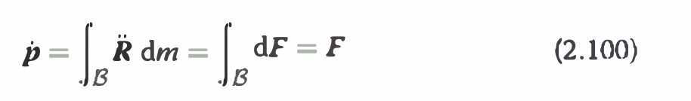
the time rate of change of the total linear momentum of a continuous
body B is equal to the total external force vector being applied to this body.
If no external force vector is applied, then the total linear momentum is conserved
and its rate is zero.

Angular Momentum
T'o find the angular momentum vector of the continuous body B about an
arbitrary point P, we write the relative position vector a- of dm to P as


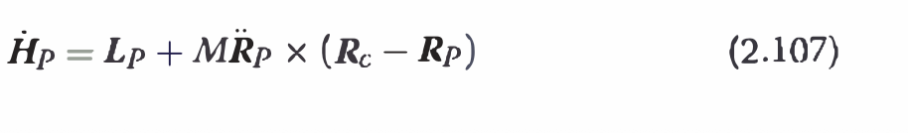
s was the case with the system of N particles, if either Re = Rp or the vector
Rp is nonaccelerating inertially, then Eq. (2.107) reduces to the Euler
Equation


Next the relationship between the angular momentum and torque about
a general point P, , is examine relative to the momentum
and torque about the system's center of mass C.

The torque Lp about a generally moving point Pis

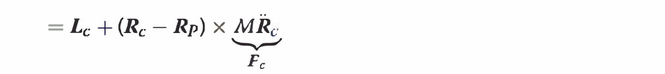
Rocket Problem

where E = Di.m/mo is the ratio of fuel spent and the initial rocl<et mass over
the time interval Di.t. Note that this change in velocity depends only on the
amount of fuel spent and F.s, not on the length of the burning time. Thus,
if a thruster produces half the mass flow rate fn as another thruster, but
burns for twice as long, then both thrusters will produce the same velocity
change Di.v. However, this result is true only if no other external forces are
acting on the body. If gravity is pulling on the rocket, then the amount of
time spent trying to accelerate the rocket will have a drastic effect on the
rocl<et velocity at burnout time.


and having units of seconds. The gravitational acceleration g used here is that
experienced on the Earth'
s surface. The higher this lsp value is, the more force
the rocket thruster is able to produce for a given mass flow rate. If the exhaust
pressure Pe is close to the ambient pressure Pa, the pressure contribution to
the static thrust F s is negligible.

to achieve higher thruster efficiencies,
the exhaust velocity Ve should be as high as possible. The faster a given
fuel particle is ejected from the rocket, the larger a momentum change (i.e.,
rocl<et speedup) it will cause

Domain A.2 — Newtonian Mechanics (Rewritten Cleanly)
A foundation for particle motion, multi-particle systems, gravitation, and the rocket equation.

1. Newton’s Laws of Motion

1.1 First Law — Inertial Motion
A particle observed from an inertial frame maintains a constant velocity unless a net external force acts on it.
If
Fnet=0,Fnet​=0,
then
v=constant,a=0.v=constant,a=0.

1.2 Second Law — Dynamics
For a particle of mass mm with velocity vv, the net force equals the inertial time-rate of change of momentum,
Fnet=(ddt)N(mv)=(dpdt)N.Fnet​=(dtd​)N​(mv)=(dtdp​)N​.
If the mass is constant,
Fnet=ma.Fnet​=ma.
All derivatives must be taken with respect to an inertial reference frame NN.

1.3 Third Law — Action and Reaction
If body 1 exerts a force on body 2, then body 2 exerts an equal and opposite force on body 1:
F12=−F21.F12​=−F21​.
These forces act on different objects but along the same line.

2. Universal Gravitation
Consider two masses m1m1​ and m2m2​ separated by
r12=r2−r1,r12=∥r12∥.r12​=r2​−r1​,r12​=∥r12​∥.
The gravitational force on m2m2​ due to m1m1​ is
F12=−Gm1m2r123 r12.F12​=−Gr123​m1​m2​​r12​.
Gravity is a conservative force, so there exists a potential
Fg=−∇Vg.Fg​=−∇Vg​.

3. Dynamics of a Single Particle

This section explains how an individual particle moves under forces, how energy and momentum evolve, and how to treat different types of forces.

3.1 Equation of Motion
For a particle of mass mm, Newton’s second law gives:
ma=Fnet.ma=Fnet​.
The acceleration is the inertial time derivative of velocity:
a=(dvdt)N.a=(dtdv​)N​.
Everything about a particle’s motion follows from integrating this equation.
f the net force does not change with time or position, acceleration is constant:
a=Fm.a=mF​.
Integrating once:
v(t)=v0+a(t−t0).v(t)=v0​+a(t−t0​).
Integrating again:
r(t)=r0+v0(t−t0)+12a(t−t0)2.r(t)=r0​+v0​(t−t0​)+21​a(t−t0​)2.
Examples:
• projectile motion near Earth,
• constant thrust spacecraft maneuvers (simplified thrust arcs).

3.3 Motion Under a Variable Force
If the force depends on time, velocity, or position:
ma(t)=F(r,v,t).ma(t)=F(r,v,t).
This becomes a differential equation that must be solved either:
- analytically (for simple forms), or
- numerically (Runge–Kutta, symplectic integrators, etc.).
This is the foundation for orbital propagation, drag modeling, gravity fields, and attitude dynamics.

3.4 Work, Energy, and Power
The instantaneous power delivered by a force is:
P=F⋅v.P=F⋅v.
The work done along a path CC is:
W=∫CF⋅dr.W=∫C​F⋅dr.
The kinetic energy is:
T=12mv2.T=21​mv2.
Work–Energy Theorem:
W1→2=T2−T1.W1→2​=T2​−T1​.
Work changes kinetic energy, regardless of how complex the motion is.

3.5 Conservative Forces and Potential Energy
A force is conservative if the work done depends only on the endpoints, not the path taken:
W1→2=−[V(r2)−V(r1)].W1→2​=−[V(r2​)−V(r1​)].
Such forces can be expressed as:
F=−∇V.F=−∇V.
Total Mechanical Energy:
E=T+V=constant.E=T+V=constant.
This principle dominates gravitational physics, orbital mechanics, and many spacecraft dynamics problems.

3.6 Linear Momentum
p=mv.p=mv.
Newton’s law becomes:
Fnet=(dpdt)N.Fnet​=(dtdp​)N​.
If Fnet=0Fnet​=0,
p=constant.p=constant.
If Fnet=0Fnet​=0, momentum is conserved.

3.6 Angular Momentum About a Point
Relative position to point PP:
r/P=r−rP.r/P​=r−rP​.
Angular momentum:
HP=r/P×p.HP​=r/P​×p.
Torque about PP:
(dHPdt)N=LP.(dtdHP​​)N​=LP​.
Angular momentum conservation is foundational in orbital mechanics (e.g., Kepler’s second law).

4. Systems of Particles

A system of particles represents an aircraft, spacecraft, or any multi-body structure before treating it as a rigid body. The goal is to convert many particles into one equivalent motion.

4.1 Center of Mass
Total mass:
M=∑mi.M=∑mi​.
Center of mass position:
Rc=1M∑miri.Rc​=M1​∑mi​ri​.
Motion of the center of mass:
Fext=Mac.Fext​=Mac​.
The system behaves like a superparticle concentrated at the center of mass.

4.2 Newton’s Second Law for the Whole System
Sum of all external forces:
Fext=Mac.Fext​=Mac​.
Internal forces cancel by Newton’s third law.
Thus, a system of many particles behaves like a single particle located at the COM, acted on only by external forces.
This is the starting point of rigid-body modeling.

4.2 Kinetic Energy Decomposition
Total kinetic energy:
T=12Mvc2+Trel.T=21​Mvc2​+Trel​.
Interpretation:
- First term → translational motion of COM
- Second term → internal motion (vibration, deformation, rotation)
This decomposition is essential in rigid-body derivation.

4.3 Total Linear Momentum
p=∑mivi=Mvc.p=∑mi​vi​=Mvc​.
If Fext=0Fext​=0,
p=constant.p=constant.
Useful for collisions.
This drives spacecraft formation flight, multi-body astrodynamics, and docking dynamics.
All internal forces cancel in pairs (Newton’s 3rd law), so the motion of the center of mass depends only on external forces.

Momentum Conservation and Collisions
If no external force acts on the system:
ptot=constant.ptot​=constant.
This principle applies even when bodies collide.
During a collision:
- forces between bodies are internal,
- the collision forces are equal and opposite,
- therefore the total momentum of the system is conserved,
- even though the internal forces may be extremely large.
However, mechanical energy is generally not conserved unless the collision is perfectly elastic:
- Elastic collision: energy and momentum conserved
- Inelastic collision: momentum conserved, kinetic energy decreases
- Perfectly inelastic collision: bodies stick together after impact
Even when energy is lost (converted to heat, deformation, sound, vibration), momentum conservation allows us to compute post-collision velocities.
Example (1D two-body collision):
m1v1+m2v2=m1v1′+m2v2′.m1​v1​+m2​v2​=m1​v1′​+m2​v2′​.
Momentum conservation is one of the most powerful tools for analyzing impacts, docking, landing, and multibody interactions in aerospace systems.

4.4 System Angular Momentum
HP=∑ri/P×mivi.HP​=∑ri/P​×mi​vi​.
External torques determine the rate of change:
(dHPdt)N=LP.(dtdHP​​)N​=LP​.
External torques control rotation; internal torques cancel.
This underlies:
- reaction wheel and control moment gyroscope dynamics,
- multibody spacecraft modeling,
- attitude control.
All internal forces cancel in pairs (Newton’s 3rd law), so the motion of the center of mass depends only on external forces.
Angular momentum of an NN-particle system about point PP:
HP=∑i=1Nri/P×mivi.HP​=i=1∑N​ri/P​×mi​vi​.
If the reference point PP is chosen to be the origin OO of an inertial frame, then
r/P=r/O,RP=0.r/P​=r/O​,RP​=0.
For a deformable body (or a cluster of particles attached to a rigid body), the velocity of each particle can be decomposed:
vi=Vc+ω×ri′+vi′,vi​=Vc​+ω×ri′​+vi′​,
where:
- VcVc​: COM translational velocity
- ωω: angular velocity of the body
- ri′ri′​: particle position relative to COM
- vi′vi′​: internal deformation velocity
Substituting into the angular momentum expression yields three terms:
HO=MRc×Vc⏟COM orbital term+Icω⏟rigid-body rotational term+∑ri′×mivi′⏟deformation term.HO​=COM orbital termMRc​×Vc​​​+rigid-body rotational termIc​ω​​+deformation term∑ri′​×mi​vi′​​​.

Interpretation
- The first term: angular momentum due to translation of the center of mass.
- The second term: angular momentum due to rigid-body rotation.
- The third term: angular momentum caused by shape change, vibration, or internal deformation.
If the internal deformation velocities satisfy:
vi′=0orvi′∥ri′,vi′​=0orvi′​∥ri′​,
then the deformation term vanishes and the system behaves like a perfect rigid body.
Thus:
HO=IcωHO​=Ic​ω
which is the familiar rigid-body angular momentum expression.
This decomposition is the foundation for understanding spacecraft flexible modes, fuel slosh, vibrating appendages, and attitude disturbances.

5. Continuous Systems (Distributed Mass)
A continuous body consists of infinitesimal elements dmdm.
When mass is distributed over a volume (like a rocket, satellite, or aircraft structure), we treat it as a continuum.
Let dm=ρ(r) dVdm=ρ(r)dV, where ρρ is density.
For a continuous mass distribution, the body can be treated as a region BB filled with density ρ(r,t)ρ(r,t). A differential mass element is
dm=ρ dV.dm=ρdV.
The motion is described by fields:
v(r,t),a(r,t).v(r,t),a(r,t).
Key integrals (mass, momentum, angular momentum, kinetic energy) involve integrating over the entire region BB:
HP=∫Br/P×v dm.HP​=∫B​r/P​×vdm.

5.1 Control Volume Choice and Time Differentiation
If the control volume BB is chosen to be the entire physical body, and the body is rigid, then BB is time-invariant in its own reference frame.
This greatly simplifies differentiation:
ddt∫Bf dm=∫Bdfdt dm.dtd​∫B​fdm=∫B​dtdf​dm.
No special integral rules are needed.

5.2 When the Body Deforms
If the body changes shape, the domain of integration moves and changes with time.
In this case, the derivative:
ddt∫Bf dmdtd​∫B​fdm
cannot be computed by simply moving the derivative inside.
Instead, one must use:
- Leibniz integral rule for deforming 1-D or simple geometries, or
- the more general Reynolds Transport Theorem (RTT) for arbitrary moving/deforming control volumes:
ddt∫Bf dm=∫B∂f∂t dm+∫∂Bf(vrel⋅n) dA.dtd​∫B​fdm=∫B​∂t∂f​dm+∫∂B​f(vrel​⋅n)dA.
The additional surface integral accounts for mass crossing the control surface (or the boundary moving through space).

5.3 Why Choosing a Time-Invariant Control Volume Helps
When modeling a rigid body:
- the shape does not change,
- the boundary of the body moves with the material points,
- volume BB can be considered fixed in body coordinates.
This avoids the complications of RTT and makes it possible to derive:
- inertia tensor
- angular momentum expressions
- Euler’s rotational equations
in a clean, compact form.
This is exactly why classical rigid-body dynamics is elegant and widely used in spacecraft modeling.

5.1 Kinematics and Velocity Field
Each material point has its own velocity:
v=v(r,t).v=v(r,t).
This field describes motion of fluids, flexible spacecraft structures, fuel slosh, etc.

5.2 Kinetic Energy
T=12∫Bv⋅v dm.T=21​∫B​v⋅vdm.
For a rigid body, this separates into translational + rotational parts.

5.3 Linear Momentum
p=∫Bv dm=Mvc.p=∫B​vdm=Mvc​.
If external forces vanish, total momentum is conserved.
For fluids or flexible systems, this integral must be evaluated at each instant.

5.4 Angular Momentum
HP=∫Br/P×v dm.HP​=∫B​r/P​×vdm.
And
dHPdt=LP.dtdHP​​=LP​.
This leads directly to the inertia tensor and Euler’s rotational equations (used later in Domain A.3 & A.4).

5.5 Governing Equations
Momentum conservation for a continuous mass:
ddt∫Bv dm=Fext.dtd​∫B​vdm=Fext​.
Angular momentum conservation:
ddt∫Br×v dm=Lext.dtd​∫B​r×vdm=Lext​.
These reduce to rigid-body equations when the body does not deform.

5.6 Why This Matters in Aerospace
Distributed-mass modeling is used for:
- fuel slosh dynamics in launch vehicles,
- flexible solar arrays,
- tethers and booms,
- aeroelastic structures,
- atmospheric entry loads,
- plume interactions and mass ejection.
It is the mathematical foundation for both rigid-body motion and advanced flight dynamics.

6. Rocket Equation & Specific Impulse

6.1 Tsiolkovsky Equation (No External Forces)
For initial mass m0m0​, final mass mfmf​, and exhaust velocity veve​:
Δv=veln⁡ ⁣(m0mf).Δv=ve​ln(mf​m0​​).

6.2 Thrust & Specific Impulse
Approximate thrust:
Fs≈m˙ve.Fs​≈m˙ve​.
Specific impulse:
Isp=Fsm˙g0.Isp​=m˙g0​Fs​​.
Higher IspIsp​ → better efficiency.

